





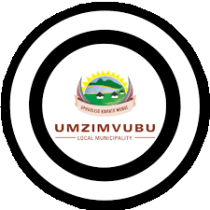

RATE PAYERS
IMPORTANT NOTICE!!!
THIS SERVES TO INFORM ALL RATE PAYERS TO UPDATE THEIR CONTACT DETAILS FOR ONLINE STATEMENT DELIVERY.
FOR MORE DETAILS CUSTOMERS ARE ENCOURAGED TO CONTACT OUR REVENUE OFFICES ON:
Ms BP Ndevu-060 386 7540/ Mr Mbusi-066 299 9071
Telephone Contact-039 255 8533

Ketshana.Avela@Umzimvubu.gov.za or

Visit our offices in KwaBhaca and EmaXesibeni.

Follow us:

